Parinaz MalekTabrizi

Project Proposal for Daycare system

**Purpose**

Parents for the daycares are like customers for a car dealer. having a website to show the environment, services, photos and staff would be helpful to encourage the parents for registering into the daycare. Having a powerful website with new UI technologies can attract the searchers and brings more trust in them in order to put their children in the daycare.

**Applicability**

This website can be useful for both the owner and the parents(customers). For both sides there are some benefits.

The owner can communicate and advertise easier, He can update the sites, with latest photos, news, availability, contact points etc. It will save lots of time for the owner. The owner can see and confirm the registration request

The customers(parents), can decide based on the price, availability, address and photos. They can decide even without going to the daycare. They can see the instructors, owner, photos of the rooms and the environment. They can reserve a spot or register online.

**Goal**

Having a website that satisfies the needs of owner and customers as much as possible. Here is the list of features in this website:

For the owner:

1. Having the capability of announcing a new free spot and update the existing free spots.
2. Having the capability of uploading some photos and modify the existing ones.

For the parents who are looking for register the children

1. Having the capability of sending a message to the owner or reserve a spot.
2. Navigating through the website, downloading the photos.
3. They can reserve a spot or register online

**Database**

**Daycaredb.sql**

1. We received some date from enrollment page which consist of information about child and parents and also if they would like to arrange an appointment for visiting a daycare. We have some information about our branch (total spot and address and name) available spot in each branch and also information about department
2. We have 9 table with this following fields

* Branch: info of the branch of daycare
* Department: info of department of each branch
* Account: info of user who sign up
* Appointment: info of any user (not need to sign up) who wants a visit date
* Parent: info of a main parent (the user)
* Otherparent: info of an other parent
* Child: info of a child and branch and department
* Product: info of products

Daycaredb ERD

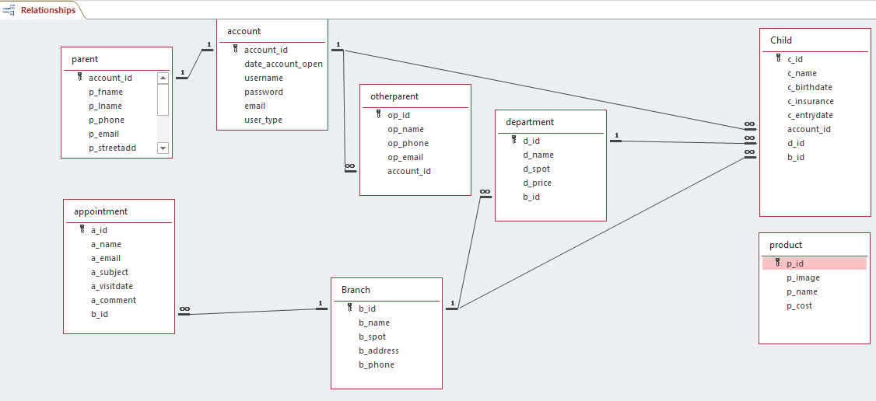

**HTML Section**

* Page: home (main.htm)

this page is a summary and also includes a login form

* Page: About us(about.htm)

this page is about the daycare

* Page: Program (program.htm)

this page is about service provides in this daycare.

* Page: tuition (tuition.htm)

this page is about prices of the service

* Page: enrollment (enrollment.htm)

this page is a form that register a child in a department of one branch

* Page: nutrition (nutrition.htm)

this page is about nutrition

* Page: gallery (gallery.htm)

this page is a gallery and keep the photos

* Page: gallery (eventsgallery.htm)
* Page: gallery (facilitiesgallery.htm)
* Page: gallery (programgallery.htm)
* Page: contact (contact.htm)

this page is a form that allows user reserve a date for visit

* Page: sign up (register.htm)

this page is a form that allows user to register in the site

**folder: php**

* accountTemplate.php

it is a class Account with four private variables

* appointment.php

it connects into database stores all data in contact.html into appointment table

* enrollment.php

it connects into database stores all data in enrollment.html into parent, child, otherparent tables

* login.php

it connects into database and search for an existing username or email and password and starts the session

* register.php

it registers a user with a username and email and pass word and stores all the data into account table

* searchproduct.php

it connects to the database and search for a specific product

* product.php

this page shows all products that user can search among different products add them to the cart

* cart.php

this page shows all products that user choose and also the service he choose in enrollment tab and total products for him

**folder: admin**

* editproduct.php

this page allows to admin change the name and price and image of all products

* edit.php

this page is a form that enable admin to modify products

We let all the users request for a visit date from contact link and then show them a message

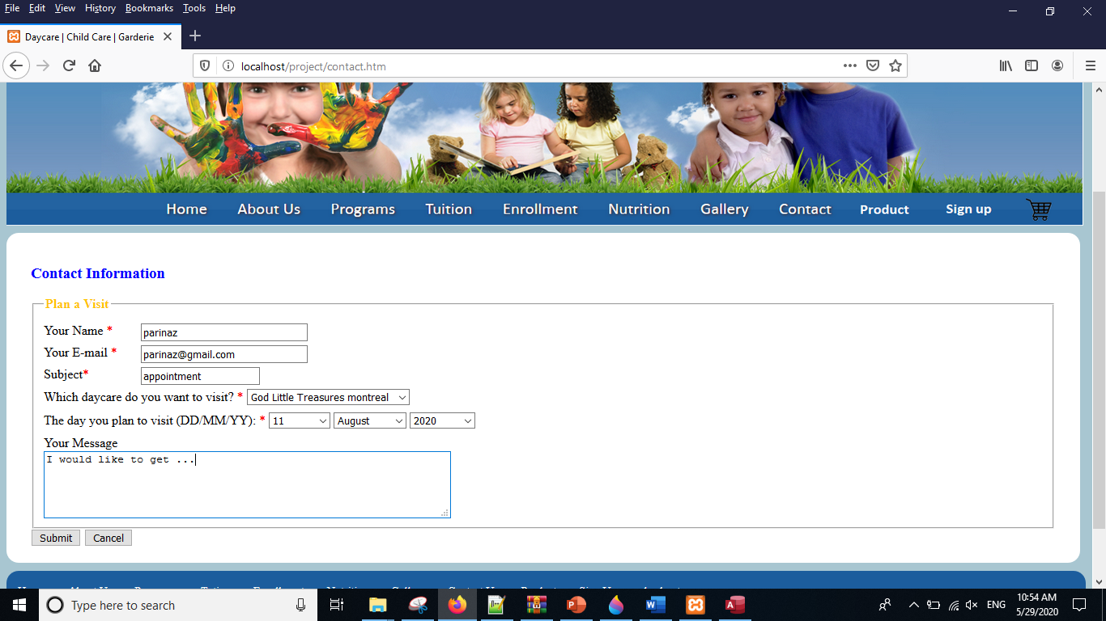

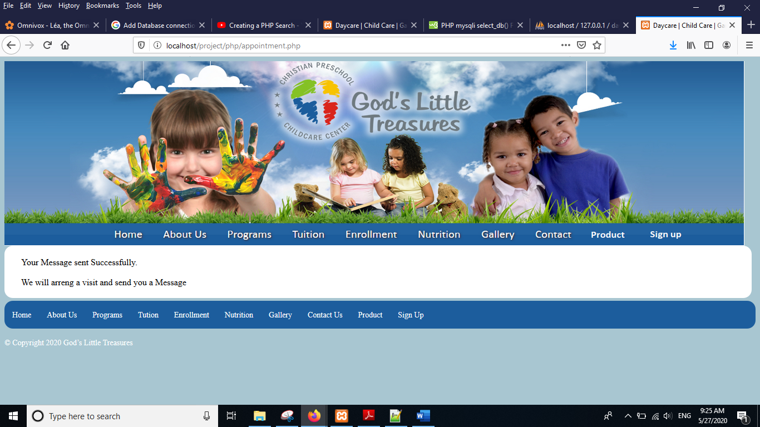

And the data will save on appointment table

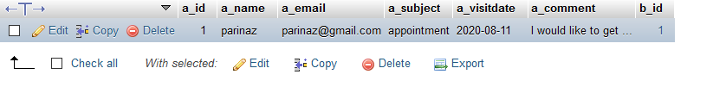

User can sign up and create a user in order to register her child and show her a message and redirect them to the main page login section and the account info will save in the account table

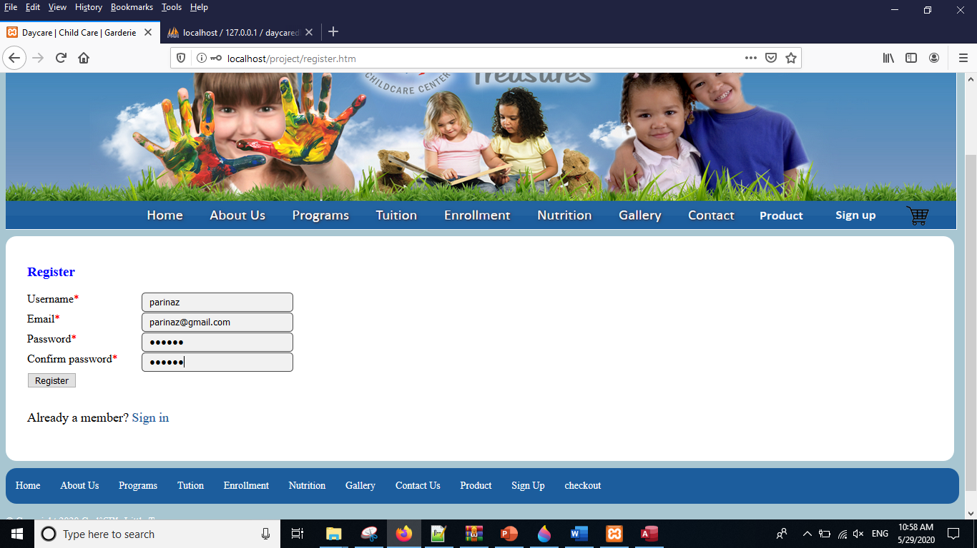

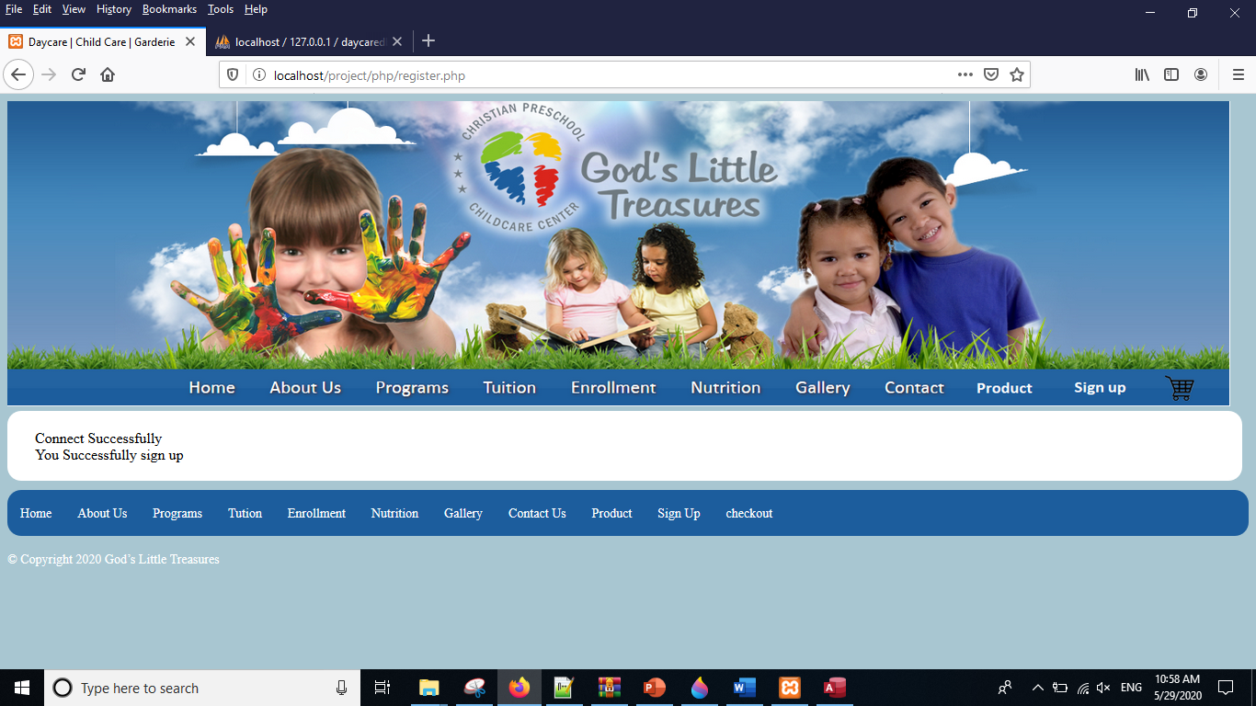

After the registration it redirects to login section in the main page.

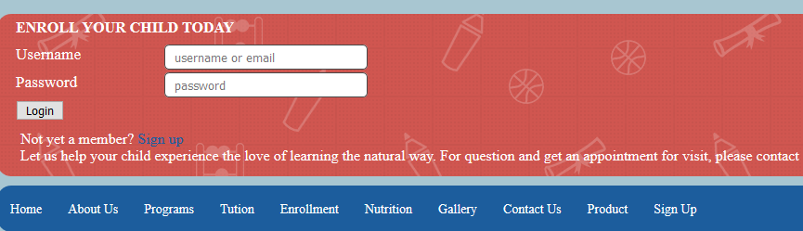

For admin site we checked it in the login info if he is a user it redirect to the main page and if he is an admin it redirect him to the editproduct.php

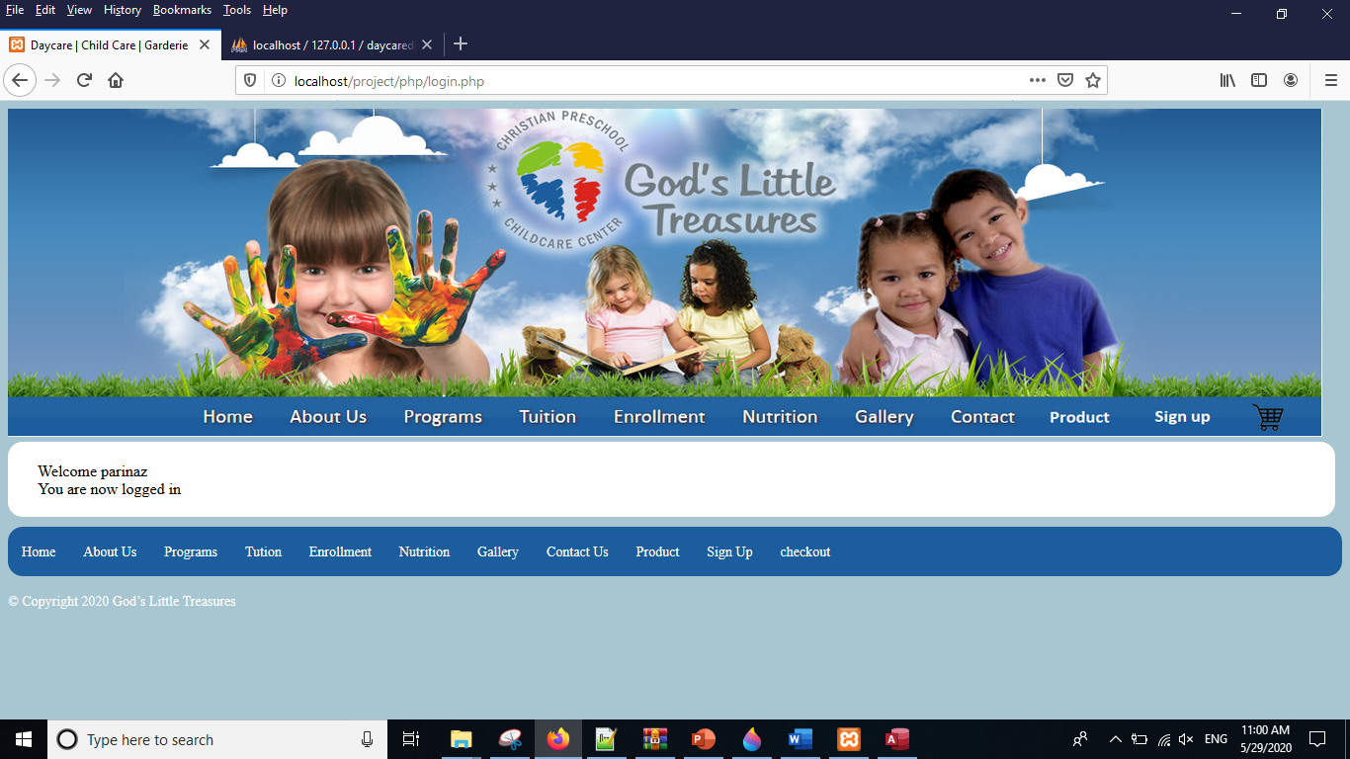

So, Product tab let the user search for a specific product and add it to his bill by search form or look for among the products it connects to database and search for specific product And the result will show on searchproduct.php and from there also we can buy product and add it to the cart

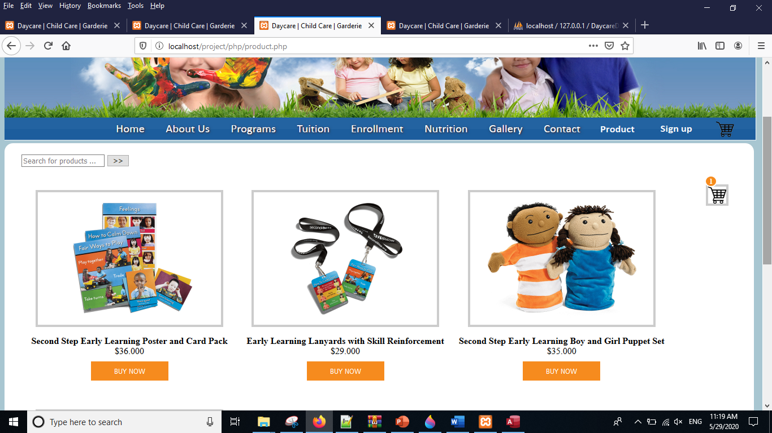

Before adding the product the cart.php is like the next image

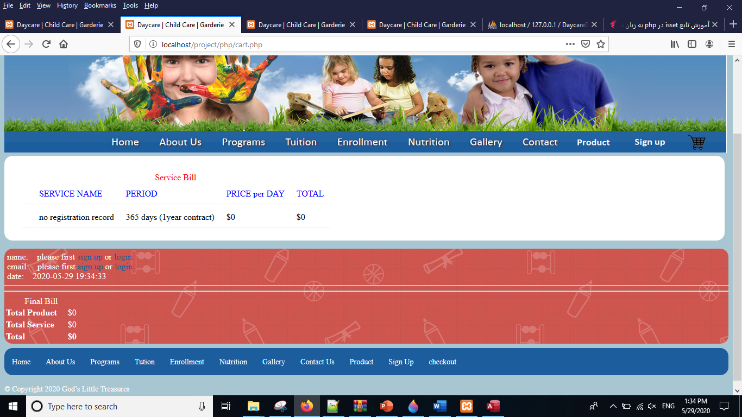

After adding product we have this page like this:

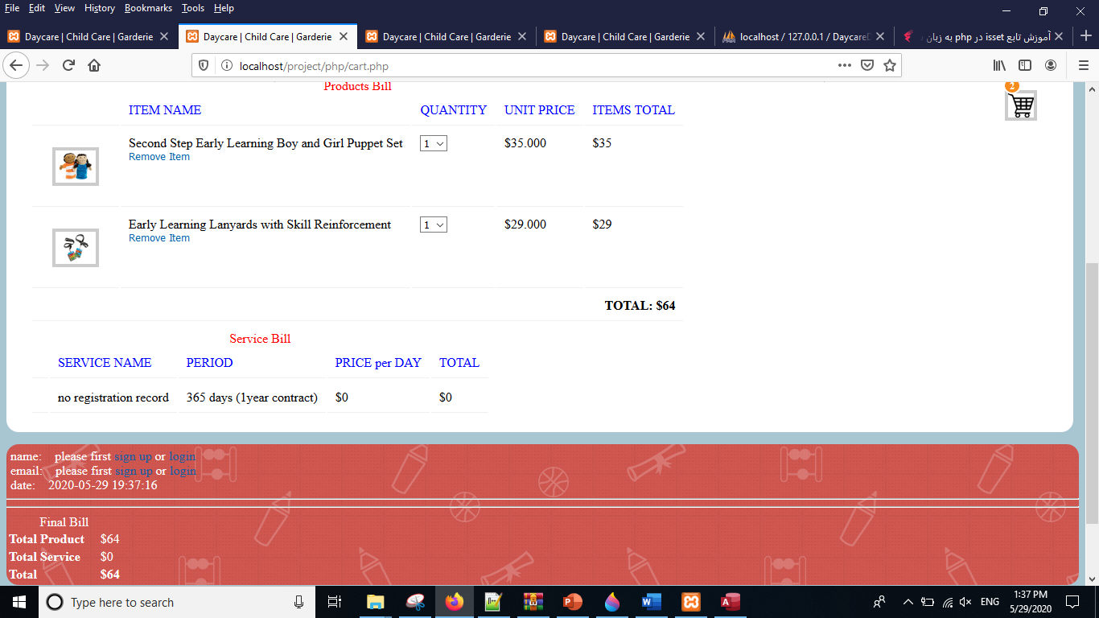

After enrollment we redirect user to cart.php in order to see the total bill. All the data will save in the parent, child, otherparent table

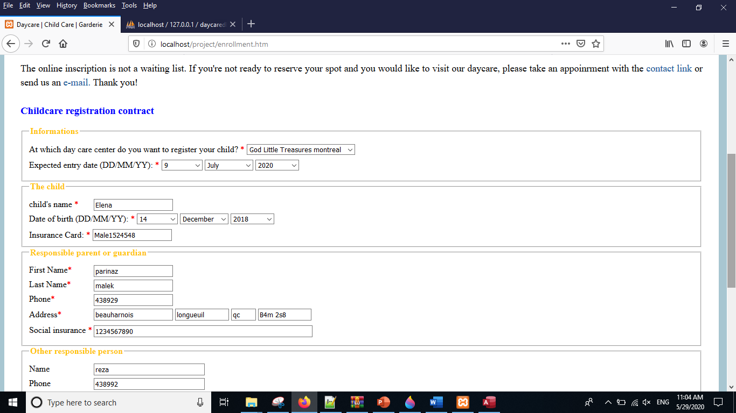

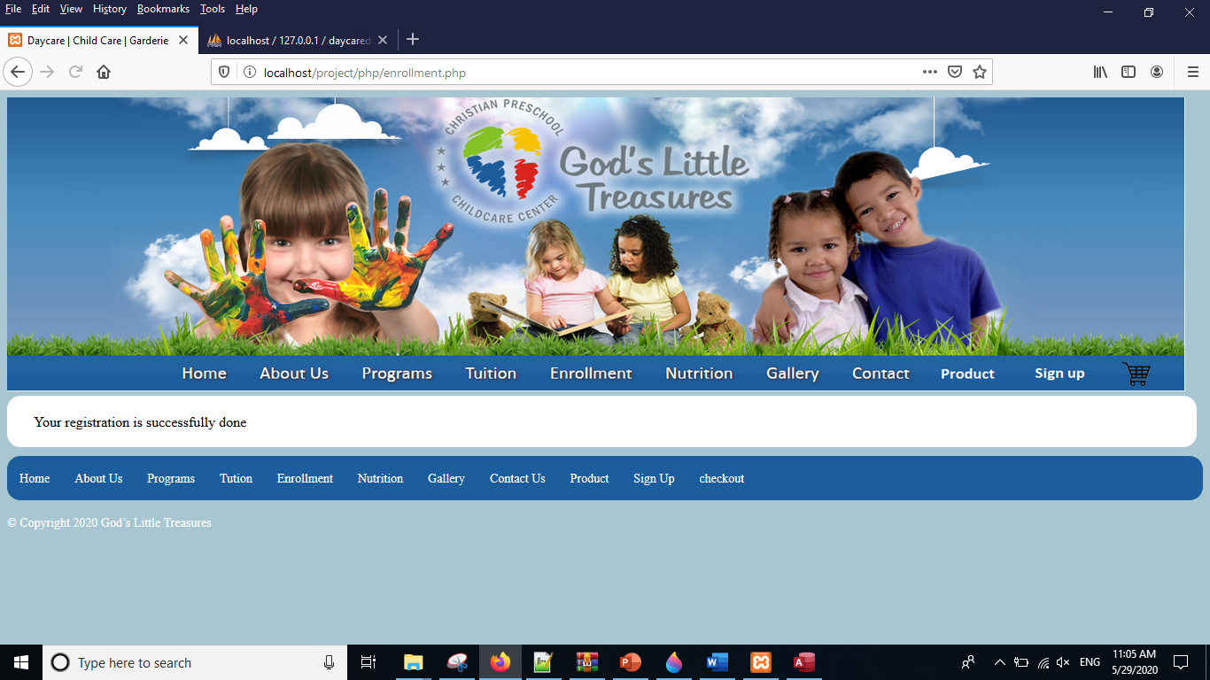

And at the end the user redirect to this page and will see the total amount

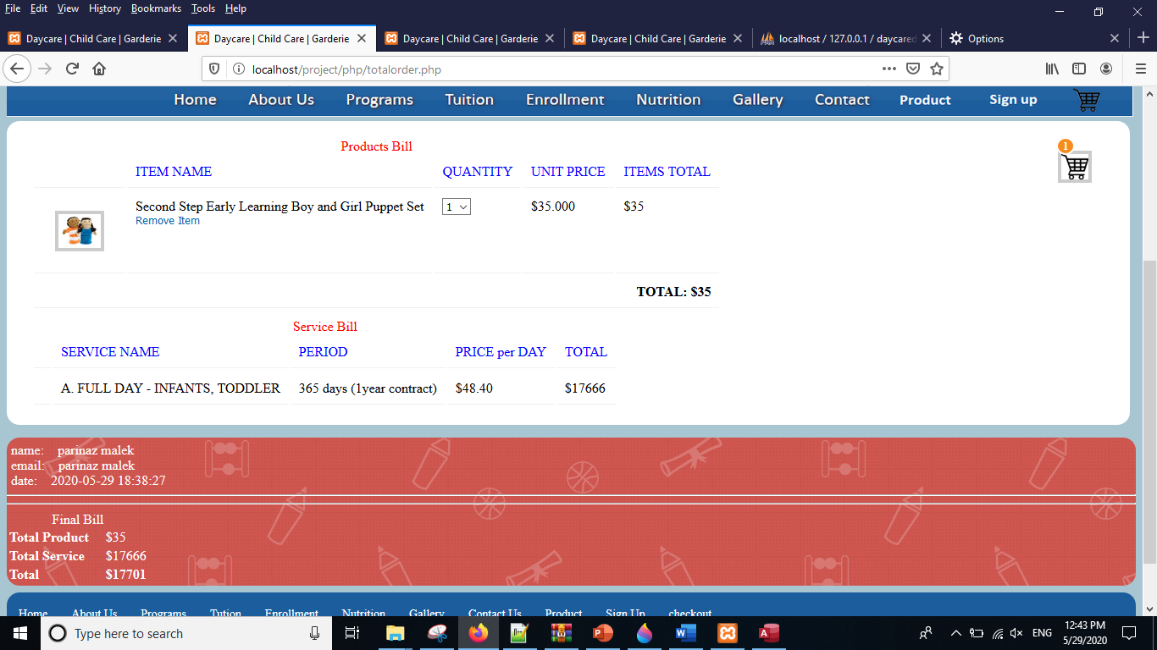

Admin Section

This page give access to admin update the products name, price and image. Here will checked if a login user is an admin or a user.

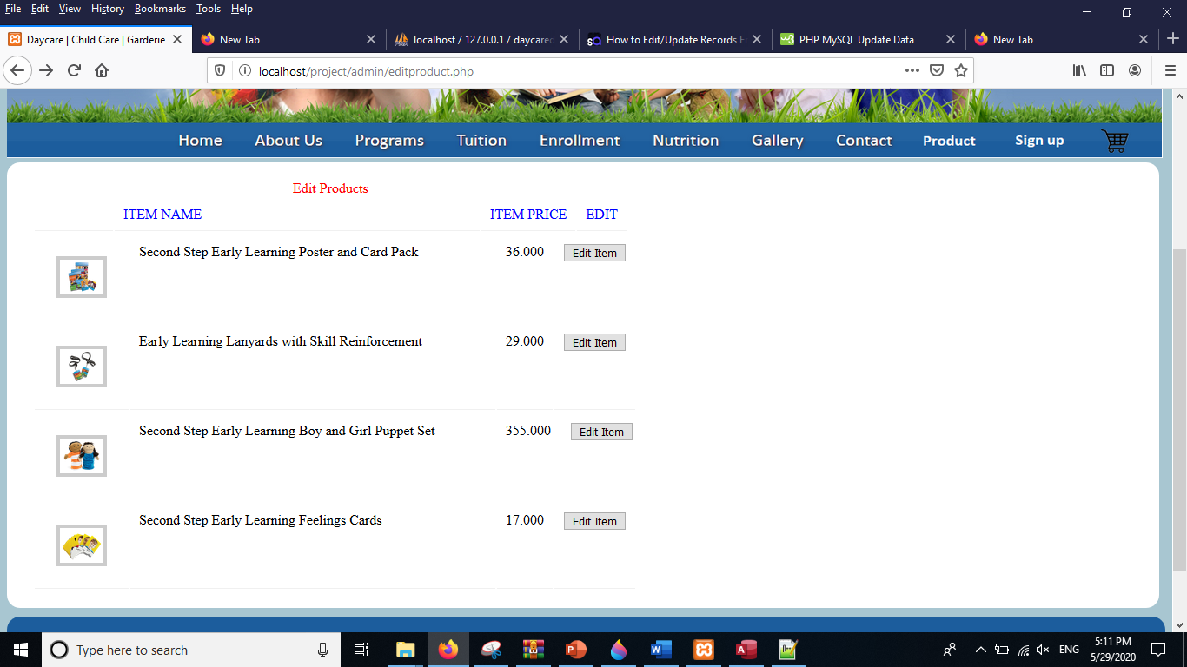

After click on edit item we will go to edit.php and we would able to modify the field that we want.

